DO EARLY REVIEWS ANCHOR LATER RATINGS?
Do early movie ratings influence those that come after? In other words, do initial reviews serve as anchors that shape how later users rate a movie, or do ratings just reflect how good the movie actually is?
RESEARCH QUESTION and MOTIVATION
Are people swayed by the first few movie ratings they see? In this project, I look at whether those early reviews set the tone for everyone who comes later, or if the trends we see in ratings are just about the movie’s actual quality.
I picked this topic because I have noticed that I often let existing reviews sway my opinions about movies. Knowing how others rated a film often affects my expectations and, ultimately, my own judgment. This realization got me curios about whether such behavior is reflected more broadly in data, and it is a common trend.
STARTING POINT, DATA and METHODOLOGY
Anchoring bias is a cognitive bias where individuals place disproportionate weight on an initial piece of information when making decisions. This initial reference point tends to skew their evaluations, which tend to remain biased toward the anchor even when additional information is available.
For my analysis, I used a MovieLens dataset with around 100.000 ratings. Each entry includes a movie identifier, user rating, and timestamp. Ratings are ordered chronologically for each movie.
I defined “early ratings” as the first 20 reviews, while later ratings are all the subsequent ones. For each movie, I computed the EarlyAvg and the LaterAvg; and ran:
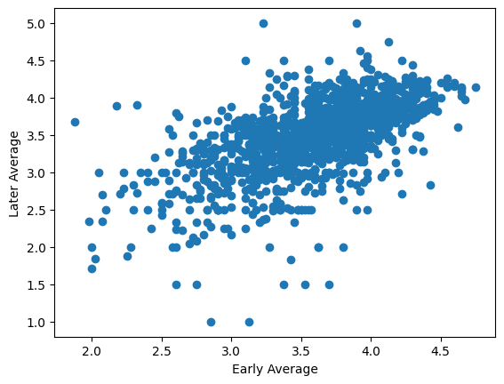
  - correlation
  - group comparison (high vs low early ratings)
  - OLS regression
Furthermore, I performed a robustness check using the first 10 ratings as “new” early.

RESULTS
What I found was a strong positive relationship between early and later ratings. The group comparison shows:
- High early ratings → LaterAvg ≈ 3.88
- Low early ratings → LaterAvg ≈ 2.87
The regression results showed:
- Coefficient (EarlyAvg): ≈ 0.65
- R²: ≈ 0.39
Additionally, results held up when defining early ratings using the first 10 observations (β ≈ 0.64, R² ≈ 0.40).
INTERPRETATION and LIMITATIONS
The findings reveal that early ratings are a strong indicator of later ratings, showing a significant level of consistency in evaluations. Movies that kick off with high initial ratings tend to continue receiving higher ratings, while those with lower initial ratings tend to remain poorly rated. The magnitude of the relationship (β ≈ 0.65) suggests that early evaluations really do have a big impact on what comes next.
This trend align with anchoring effects. Early ratings may act as a reference point that shapes users’ expectations and how they perceive the movie. When users are exposed to existing ratings, they might not stray too far from their initial benchmark.
At the same time, this persistence can also be tied by the actual quality of the movie. High-quality films are likely to receive positive ratings both early and later, while lower-quality movies receive consistently lower ratings. As a result, the observed relationship cannot be interpreted as purely behavioral without further analysis.
To tackle this issue, further analysis would require:
- Controlling for movie quality
This could involve looking at average ratings across different platforms, critic scores, or fixed effects for each movie.
- Using experimental or quasi-experimental data
For instance, comparing ratings in settings where early reviews are visible versus hidden, or exploiting situations where early ratings vary randomly.
- Analyzing changes within movies over time
Studying whether deviations in early ratings (like unusually high or low initial reviews) have a lasting impact beyond what would be expected from quality alone.
- User-level analysis
Looking into whether individual users adjust their ratings after observing previous reviews.
CONCLUSION
This project shows that early ratings do seem to matter for what comes next. On average, higher early ratings are associated with higher later ratings (β ≈ 0.65), and they explain about 40% of the variation. The relationship is noticeable but not overwhelming, which suggests that early reviews play an important role, while other factors, like the actual quality of the movie, also influence how people rate it.
However, we should be careful with these findings, as they may also reflect underlying differences in movie quality rather than behavioral bias alone. Distinguishing between these explanations requires more advanced methods and richer data.
Overall, this analysis highlights how initial information can play an important role in shaping collective evaluations, while also pointing to the difficulties of identifying causal behavioral effects in observational data.

